New corrections and modification to the Sylc export Admin and user dashboard 4-7

**Admin corrections and changes**

Please make the following changes and corrections inside the sylc admin <http://seobranddev.com/sylc-corporation/voiture/admin/login.php>

**1pending**

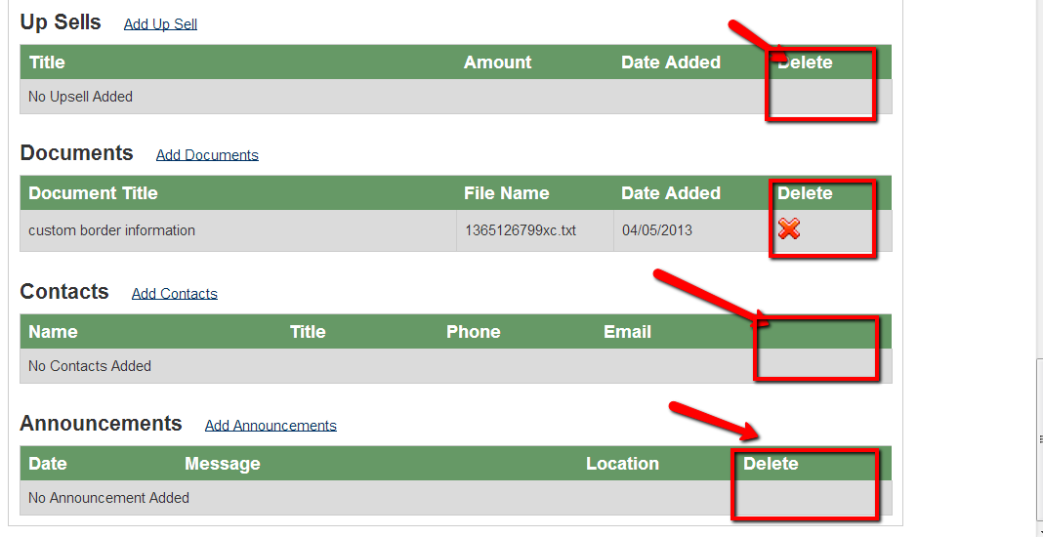

Inside the customer info page, please proceed with replacing the delete columns text with “Actions”.

Also please change the delete button instead display the **delete** and **Edit** buttons as shown below for each of the section shown in the screen shot above including the fees section also.



**Delete buttons have been replaced. We have implemented edit functionality on fees, upsell, announcement, We are working on other parts .**

**2**

When the contract still hasn’t been sent , the button should be displaying this text “**Send contract** ” instead of “**resend contract** ”

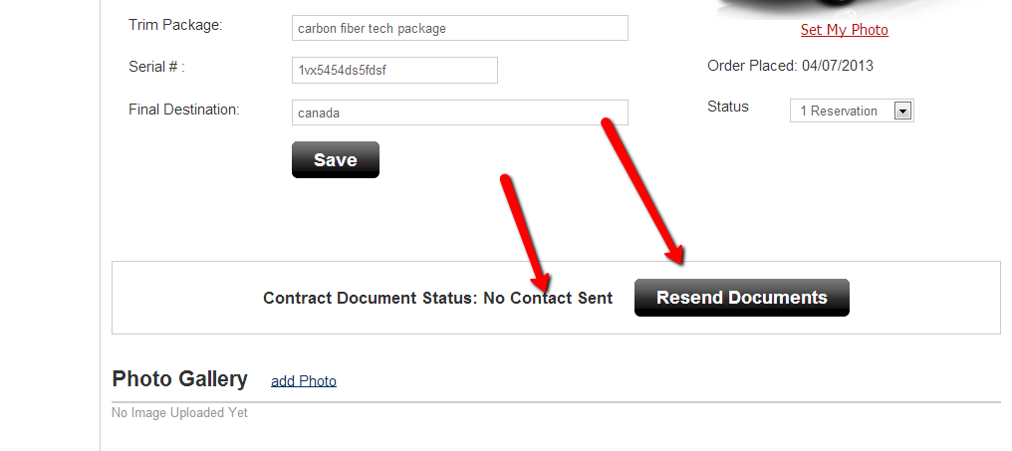

**Done**

**3**

After I click on the **resend documents** button , I went and checked my inbox and I noticed that the contract has not been emailed to me

Please make sure the contract is being sent correctly by email . I made a test with my gmail account and I made on test with my seobrand email account and both test failed where I never received my contract by email or password to login.

Also when the admin would reset the password of a client , the email associated to the password that has been reseted should be emailed an automatic notification with the new user name and password .

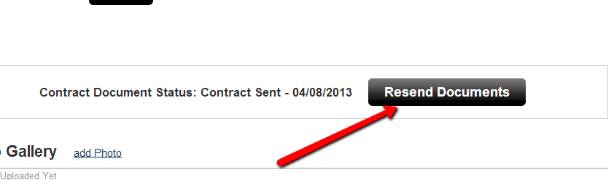

**There is some issue with the emails at seobrand for now, it will work automatically.**

**4**

Using chrome I realized that the sylc logo is not being displayed

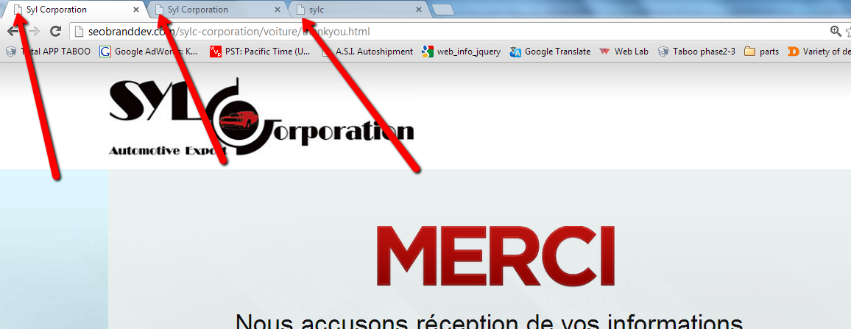

Please make the correction to these pages

Admin Panel: <http://seobranddev.com/sylc-corporation/voiture/admin>

**Done**

Admin Panel Still not done : <http://seobranddev.com/sylc-corporation/voiture/admin>

**Done. Please remove your browser cache.**

**5**

I made a test where I have same an image as a PNG file and I noticed that the background image of the building is being hidden . Please fix this

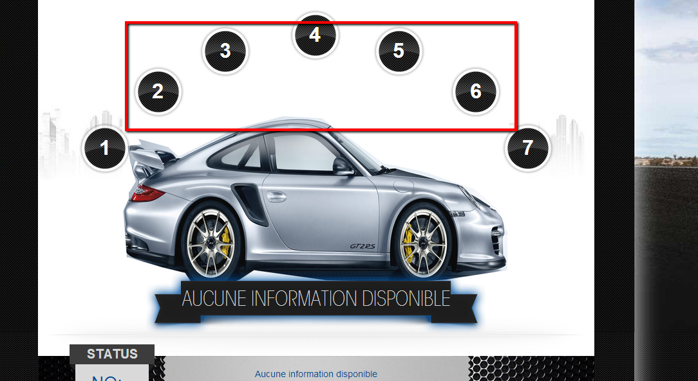

**You have uploaded the PNG image with white background due to which building images have been hidden.**

Error occurred !!!!

Error 1

I tried uploading the image and I got this error

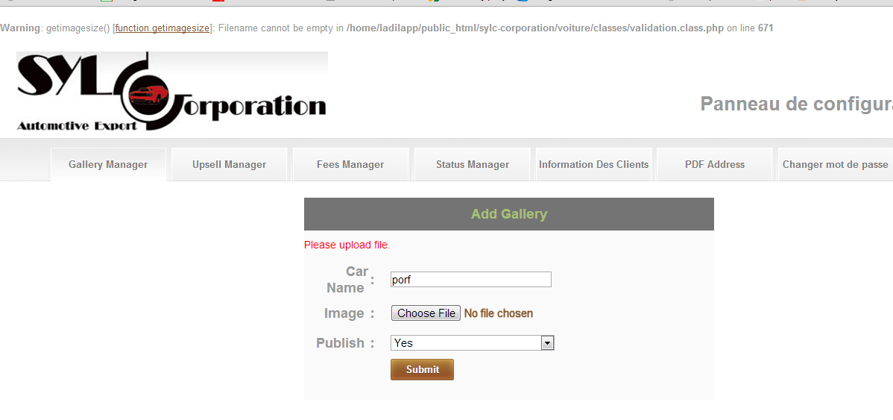

I tried uploading the png image again and I got this error shown below

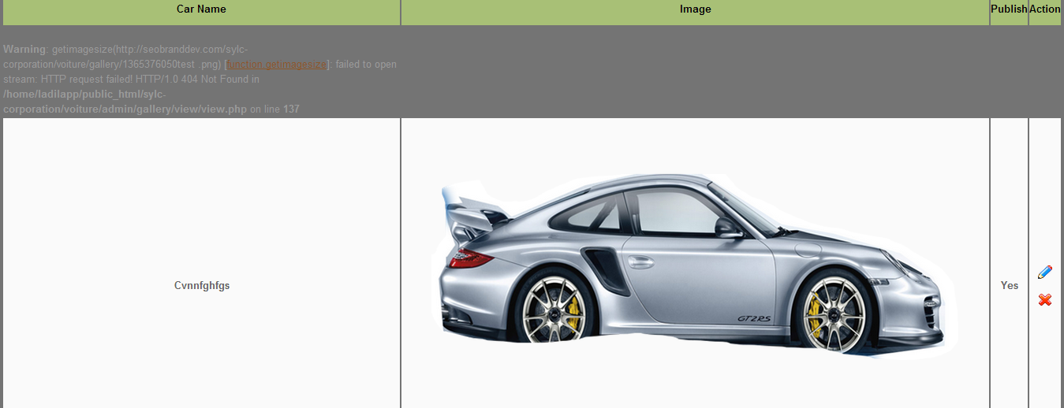

**Working fine, I have uploaded two cars images used same image as you were trying to upload.**

**6**

I get this error message after trying to enter a phone number when adding a new contact

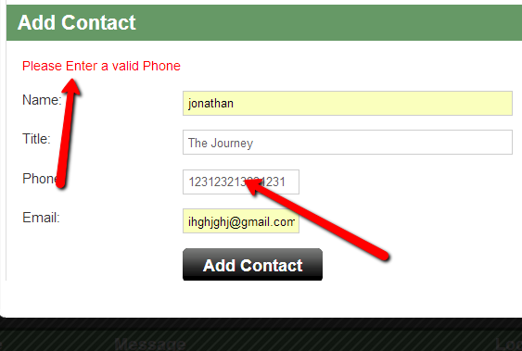

Please remove any validate for the phone number so that the admin will be able to enter any desired format (8005665452 ext 5421)

**Done**

**7**

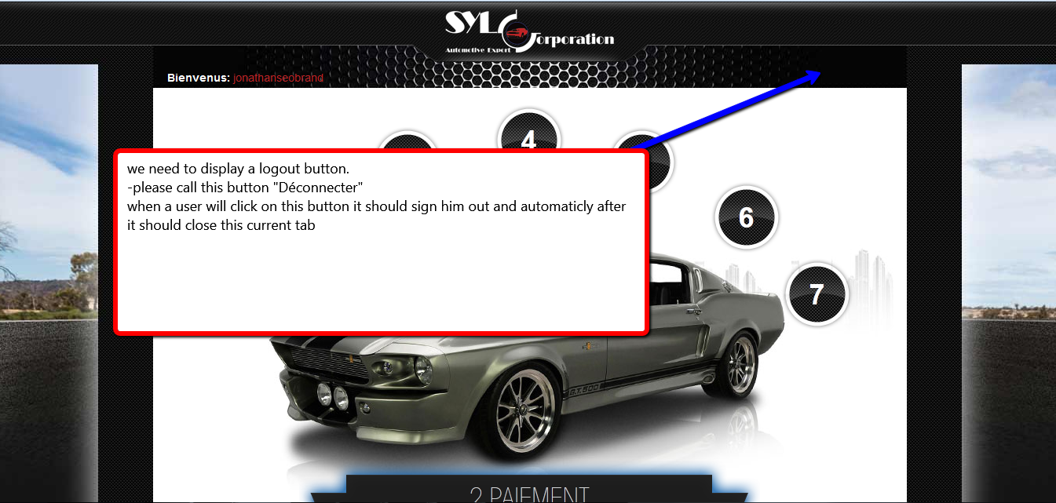

**When the user will click on the deconnecter button it should sign out the user from his session also close the current tab window he was currently viewing**

**We are working on it.**

**8**

Please move the location of the logout button

Please display remove the “deconnexion” tab button and instead please display it as a button where circled in red in the picture below

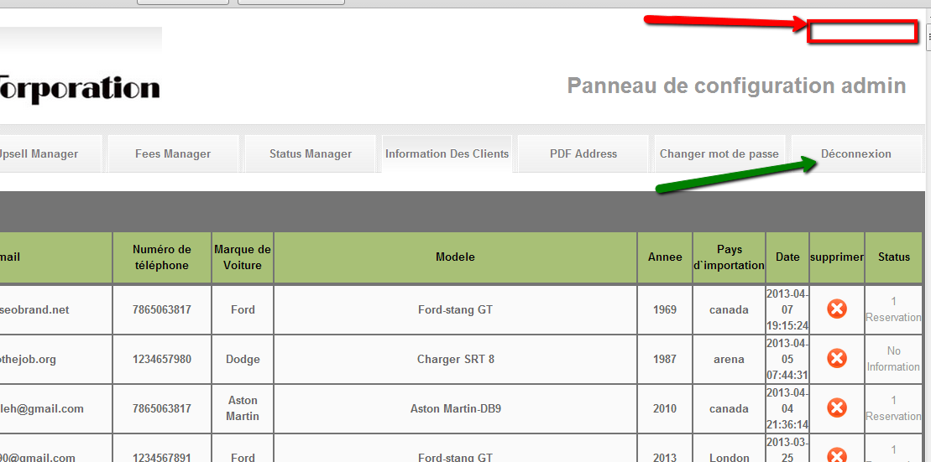

**Done**

**9**

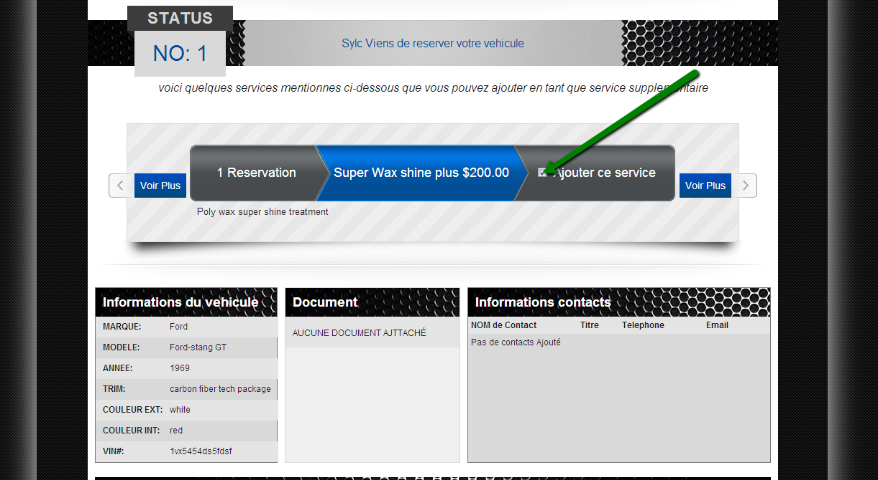

When a user will click on the checkbox of any upsell(as shown in the picture above ) , he should be then presented with the following pop up window (as shown in the wireframe image shown below)

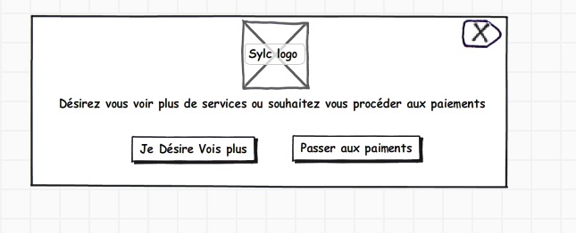

**Need a discussion on this point.**

10

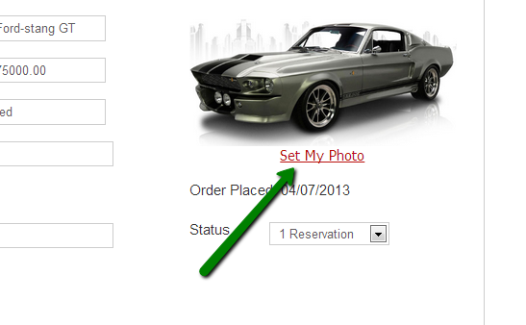

Inside the customer info page , when I click on the “set my photo link” (shown in the picture above ) it will open it pop up window (as shown below)

-please replace the text “**set my photo** ” currently displayed next to each option button(as shonw below highlighted in red) , with the name that was entered “car name ” text box (as shown in the second screen shot below)

**Done**

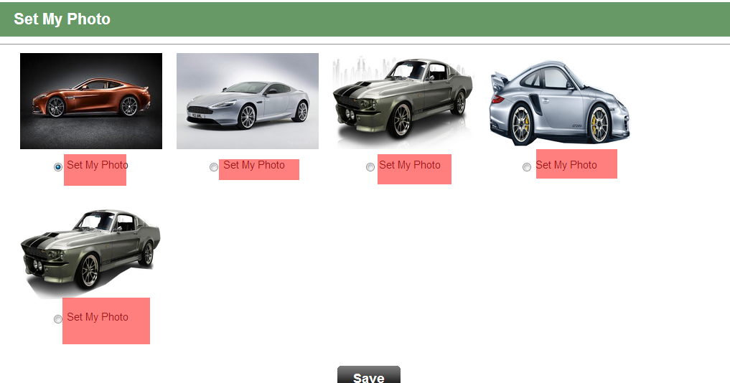

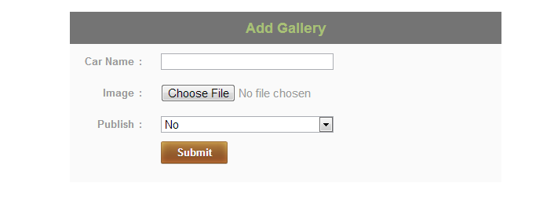

**DONE**

11

All the names of the columns that the user is presented on a table should be a clickable link to be able to sort the table .

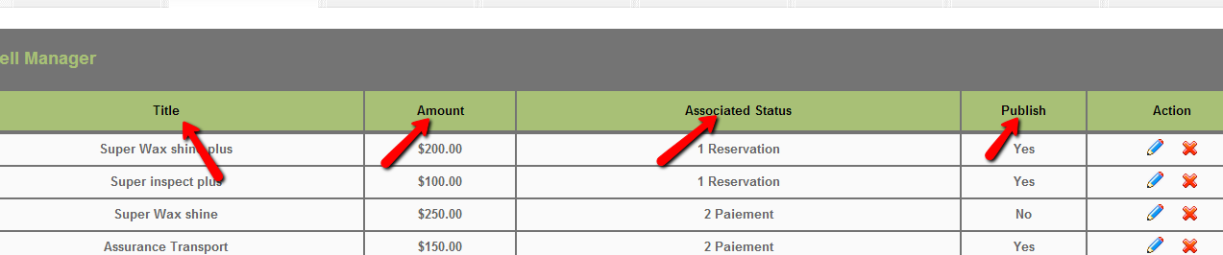

Please make sure this task is done for the following page

Gallery manager, upsell manager , feel manager , status manager and information des clients

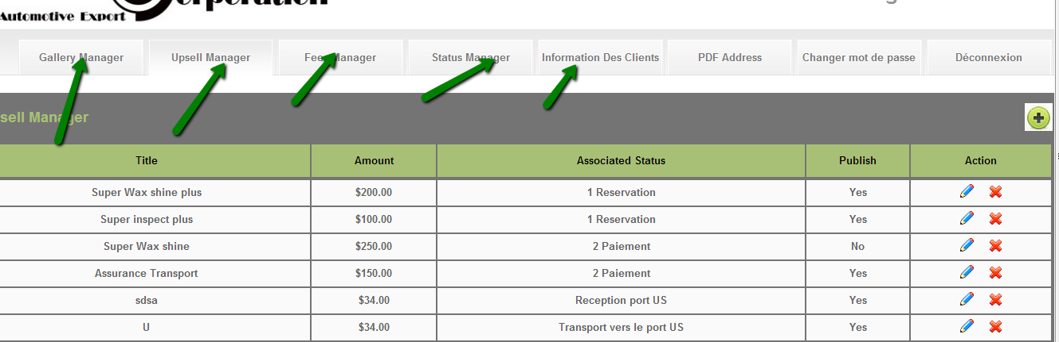

**We are working on it.**

12

Please make sure to fix the design of this button shown here and make sure the light grey background is removed

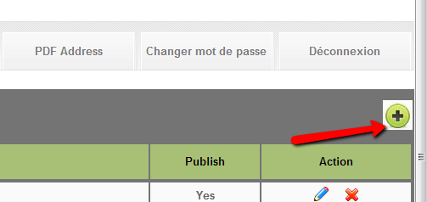

Please make sure this task is done for the following page

Gallery manager, upsell manager , feel manager , status manager

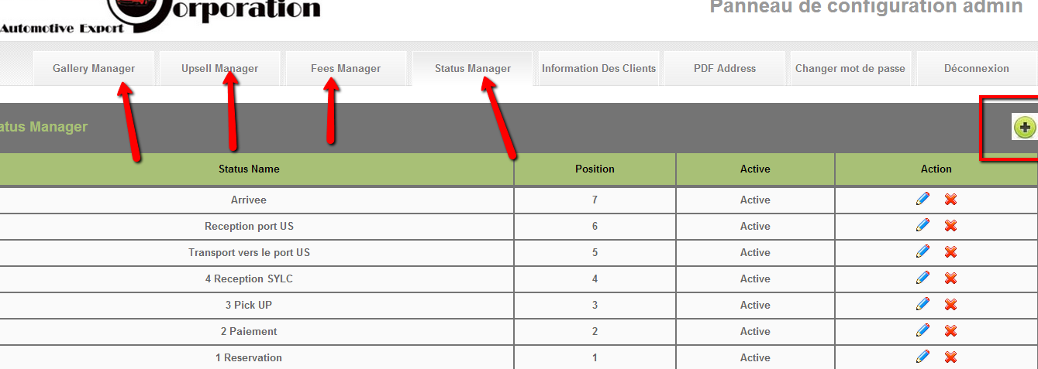

**Done**

Aucune annonce Ajouté

information du client

nom:

Prénom:

Adresse:

Ville / Province (État):

Numéro de téléphone:

email:

pays:

Code postal:

Date:

facture:

Destination finale:

informations du véhicule

Quantité:

marque:

Modèle:

année:

Description de l’Auto:

N ° de série(vin#):

couleur:

Prix:

Frais de transport:

Frais d'expédition:

Commission:

frais supplémentaires

Description des Frais:

Montant:

frais (Fedex, frais doc, frais bancaires)

Description des Frais:

Montant: